**Reimaging Laptops using USB**

This guide will enable you to reimage many laptops at a time without having to have them plugged into power and only briefly needing an ethernet cable.

Preparing MDT

Download these files:

* [Microsoft Deployment Toolkit](https://www.microsoft.com/en-us/download/confirmation.aspx?id=54259)
* [Windows ADK and Windows PE](https://docs.microsoft.com/en-us/windows-hardware/get-started/adk-install)

Open MDT and create a New Deployment Share

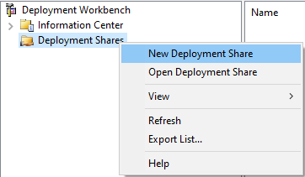

Choose where to store your deployment (I use a USB hard drive to take with me)

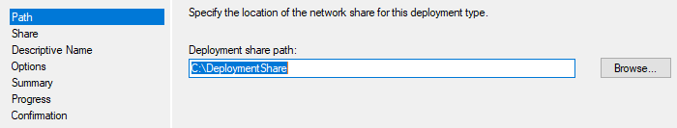

Accept all defaults and uncheck all options

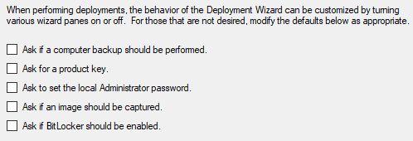

Importing the Operating System

Download these files from your [Software Library](https://educationwaeduau.sharepoint.com/sites/educationcontent/5070/SitePages/SoftwareLibrary.aspx) (change 5070 to your site code)

* Win 10 Release 20H2
* O365 package for Custom images - read O365 usage first

Mount the Win 10 Release 20H2 ISO

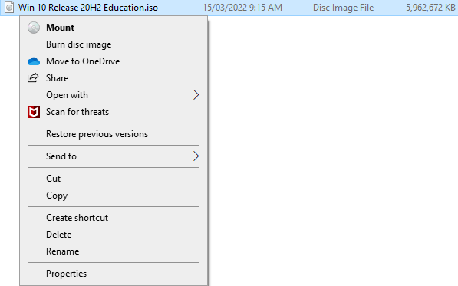

Inside your deployment, right click Operating Systems and select Import Operating System

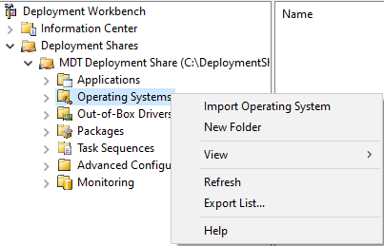

Import the full set of source files

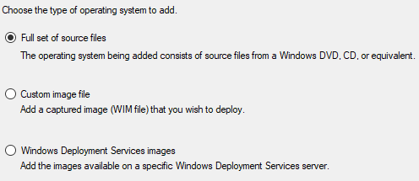

Select Browse and navigate to the drive you mounted the ISO on

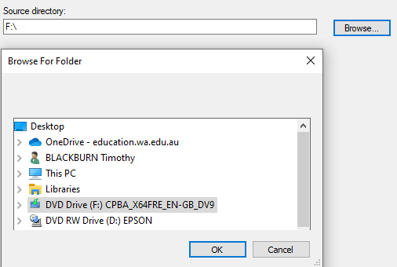

Change the directory name to add the release version so you can add newer versions later



Then accept all defaults to import the OS to your Deployment

Inside Operating Systems, delete all the versions you don’t need

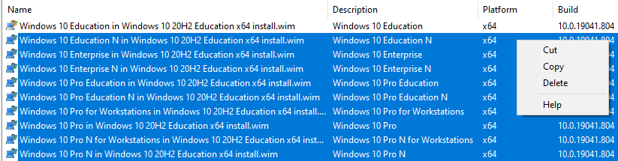

Importing Your Applications

Put each installer into its own file along with associated installer files

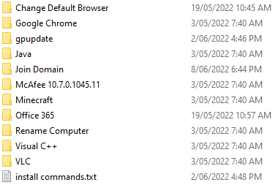

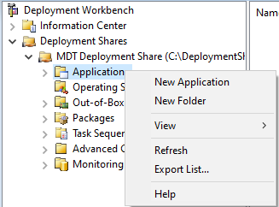Inside MDT, right click on New Application and **give it a name**

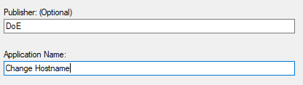

Browse to your Programs Directory and select the application

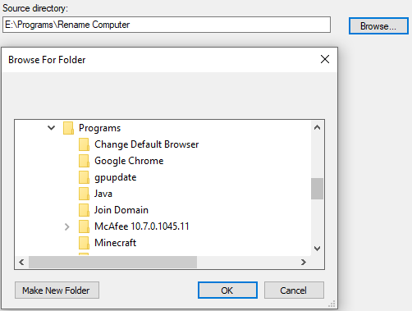

Specify the command to run or install your application, then accept the defaults until the end

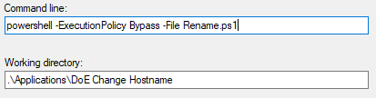

Create the Sequence Task

Right click on Task Sequence and select New Task Sequence

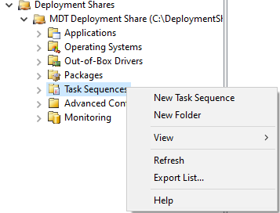

Give it an ID so we can automatically run it from the ISO image and a name for MDT

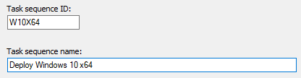

Select the Operating System to deploy



Create the account

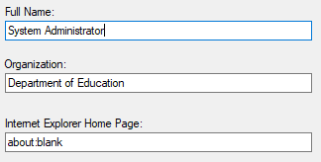



Right Click your newly created Task Sequence and select Properties to configure

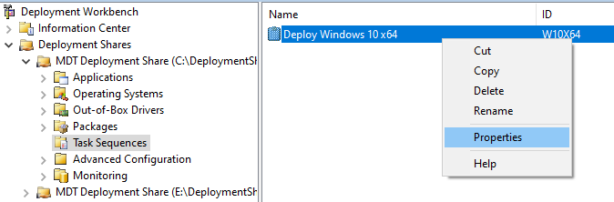

Navigate down to Install Applications and change the name to the Application Name

Select Install a single application and Browse for it to select one from your Applications Folder

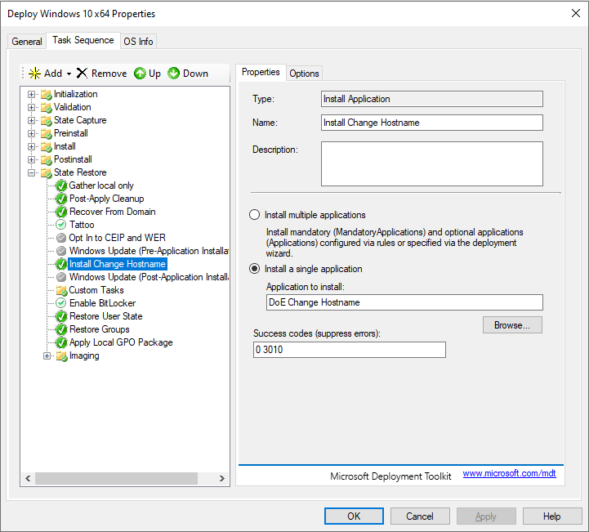

Right Click on the first application and select Copy right click again and select Paste

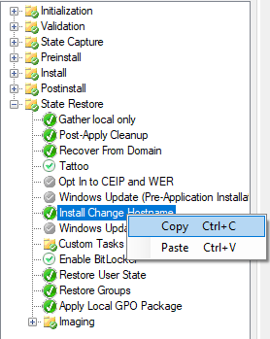

Then change the name and select the application from Browse

Put a Restart a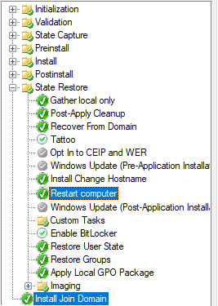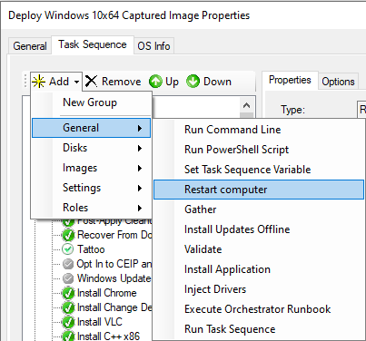fter installing all of the applications

Then move the Join Domain Application to the end of the script

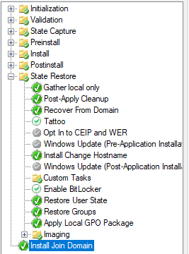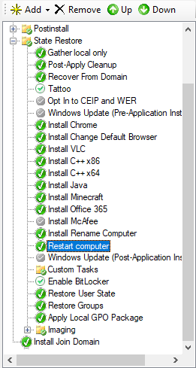

The Final Product

Preparing the Drivers

On a blank USB, copy the Export_Drivers.ps1 script and plug it into a laptop you have PXE installed the latest Windows on. Then open PowerShell and run the script

powershell -noprofile -executionpolicy bypass –file Export_Drivers.ps1

This will create a folder on the USB of drivers we can import into MDT to deploy

In MDT, navigate to Out-of-Box Drivers, right click and select New Folder and give it a name similar to the name of the folder on your USB

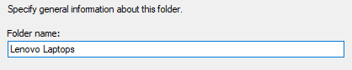

Then right click on the new folder and select Import Drivers

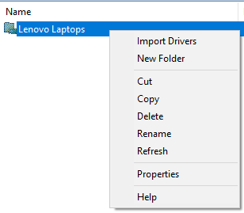

Select the folder the Export_Drivers.ps1 script created to import them

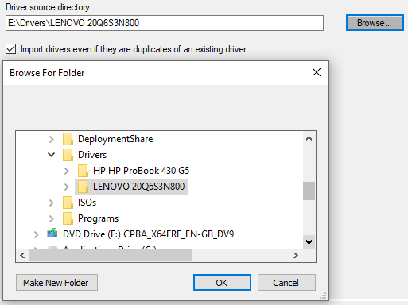

Once they have been imported, create a Selection Profile if you wish the ISO to only have specific drivers

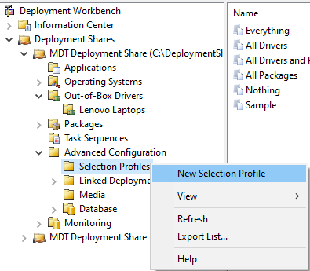

Give it a name



Then select the items you wish to install on your ISO

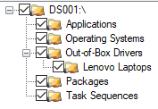

Create the ISO

Inside MDT, navigate to Media and select New Media

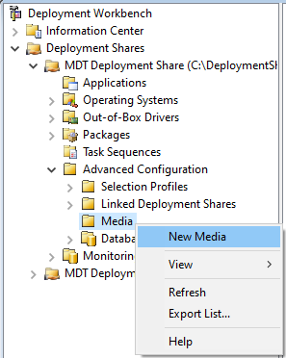

Select which folder you are going to build the ISO in and select your selection profile

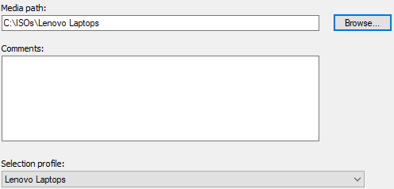

Now configure the ISO by right clicking the new Media Profile and selecting Properties

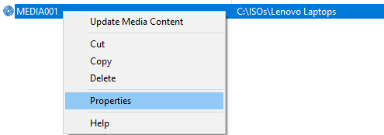

Rename the ISO file and untick x86

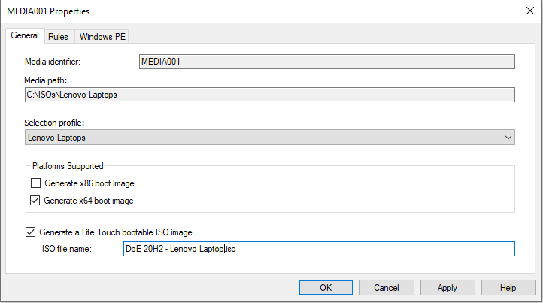

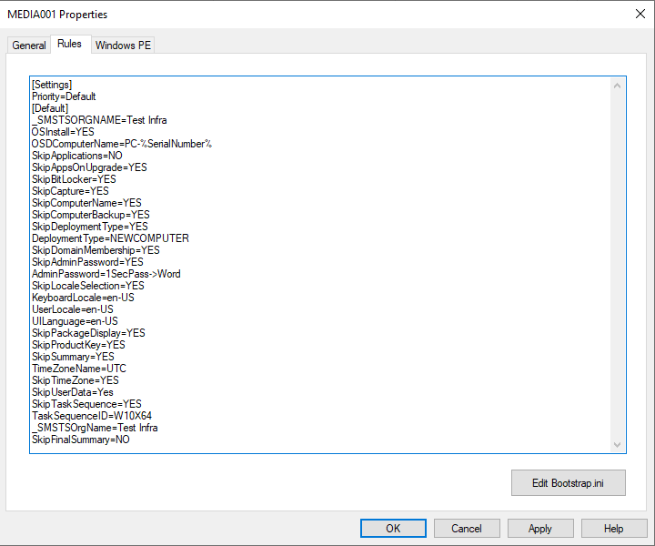Then copy the [Deployment Rules](https://raw.githubusercontent.com/zeetum/WindowsDeployment/main/MDT/DeploymentRules). Paste the text from Bootstrap.ini into the Edit Bootstrap.ini button at the bottom of the screen and everything below into the open textbox. Make sure you change the password.

Also note the TaskSequenceID for the task sequence we created before

Navigate to Windows PE and select the Selection profile that contains all your drives and click Include all drivers from the selection profile

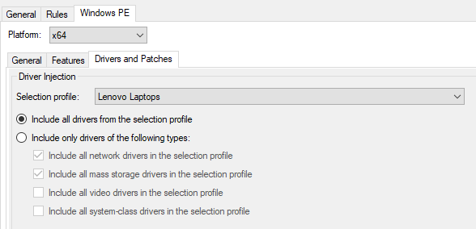

Generating the image

Right click on your deployment and select Update Deployment Share

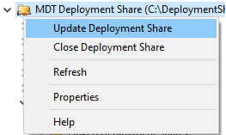

Select Completely regenerate the boot images, accept all the defaults and wait to finish

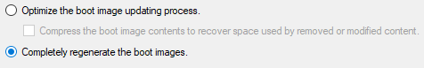

Now navigate back to Media and right click on the Media file we created and select Update Media Content

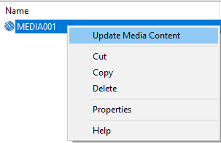

Now you should find the ISO in the Media path you specified when you created the new Media file.